

**DIM 3014**

**INTERACTIVE DESIGN & MULTIMEDIA**

**ASSIGNMENT 1: IDENTIFY THE USAGE OF INTERACTIVE LEARNING IN INTERACTIVE DESIGN & MULTIMEDIA**

**PREPARED FOR**

PUAN NUR SAHIDAH BINTI BASHIER

**PREPARED BY**

ANIS BASYIRAH BINTI ANAS MUKHSIN

(MIN18050120)

**DUE DATE**

8th JULY 2020

**Table of Content**

|  |  |  |
| --- | --- | --- |
| **No.** | **Content** | **Page** |
| 1. | Definitions (Citations) | 3 |
| 2. | Functions | 4 - 6 |
| 3. | Types of Technique | 7 – 9 |
| 4. | Benefits | 10 |
| 5. | Example | 11 – 15 |
| 6. | List of references | 16 |

1. **Definition (citations)**

Courseware is a term that combines the terms “course” with “software.” It is a software that contains educational content, instruction, and instructional strategies. Its meaning originally was used to describe additional educational material intended as kits for teachers or trainers or as tutorials for students, usually packaged for use with a computer. Courseware learning is the process of learning through Courseware. CAI and educational software are terms that are also used to describe Courseware. CAI stands for computer assisted instruction or computer aided instruction. CAI is a program that contains instruction contents and assistance to instruction using a computer. It is difficult to distinguish between CAI and courseware. Sometimes Courseware and CAI were used as the same concepts in reference to a sort of educational software which refers to all types of software for education.

Interactive Learning is a pedagogical approach that incorporates social networking and urban computing into course design and delivery. Interactive Learning has evolved out of the hyper-growth in the use of digital technology and virtual communication, particularly by students.

1. **Functions**

Interactive learning is a more hands-on, real-world process of relaying information in classrooms. Passive learning relies on listening to teachers lecture or rote memorization of information, figures, or equations. But with interactive learning, students are invited to participate in the conversation, through technology (online [reading](http://www.scholastic.com/resources/article/learn-to-read/) and [math](http://www.scholastic.com/resources/article/online-activity-round-up/) programs, for instance) or through role-playing group exercises in class.

In addition to engaging students who are raised in a hyper-stimulated environment, interactive learning sharpens [critical thinking](http://www.scholastic.com/resources/article/think-about-it-critical-thinking/) skills, which are fundamental to the development of analytic reasoning. A child who can explore an open-ended question with imagination and logic is learning how to make decisions, as opposed to just regurgitating memorized information. Also, interactive learning teaches children how to collaborate and work successfully in groups, an indispensible skill as workplaces become more team-based in structure.

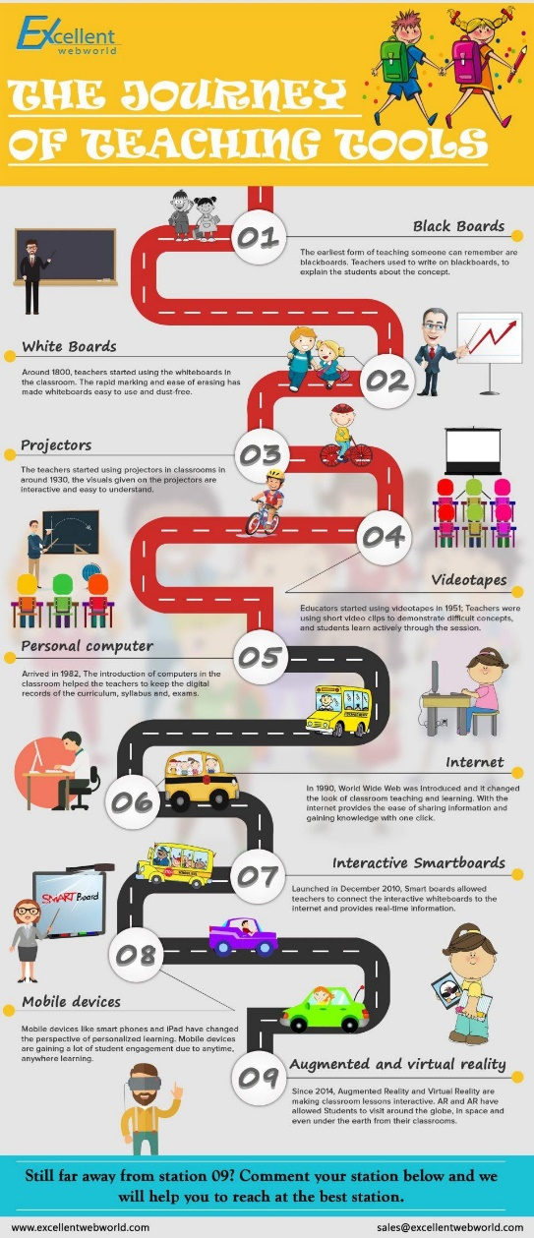

Media considerations.

The various media employed for CBT courseware production must, together, perform the basic functions of:

* Storing the lesson material
* Communicating the subject matter to the student
* Allowing student feedback
* Storing students' responses.
* Feedback is important since it enables:
* Student responses to be monitored
* The sequencing of lesson material to be controlled by these responses.

As we have suggested previously media may be thought of as communication channels, which may offer either unidirectional or bidirectional information flow. The channels for use in a CBT system will vary quite considerably with respect to the facilities they offer in the context of the basic functions listed above and of their [directionality](https://www.sciencedirect.com/topics/engineering/directionality).

When people communicate with each other they use only a relatively small number of primitive modes. These involve the use of text (including numbers), pictures and actions. The last of these, of course, will encompass all forms of non-verbal communications. Some of the many ways that have been used to support the requirements of these basic modes are listed below:

* Printed tables
* Printed narrative
* Recorded spoken narrative
* Live spoken narrative
* Still pictures and graphs
* Silent motion pictures
* Recorded spoken narrative with pictures (tape/slide)
* Live spoken narrative with pictures (an illustrated lecture)
* Sound motion pictures or video recordings
* Man/computer communication through a computer terminal
* One-to-many live tutorial (with ‘props’)
* One-to-one live tutorial (with ‘props’)
* Integrated multimedia communication techniques.

A comparison of the directionality of some of the support channels listed above is presented in Figure 1. In this diagram, typical sources of information might be a teacher or a courseware author; students and trainees would then be destinations (or recipients) of information. Each of the channels listed above and in Figure 1 differs with respect to its capacity to communicate information and its ‘interactivity’. This term is used to describe the balance and frequency of information flow between an information donor and recipient. High interactivity is achieved when the roles of donor and recipient interchange with substantial rapidity, as might be the case in a human/computer dialogue.

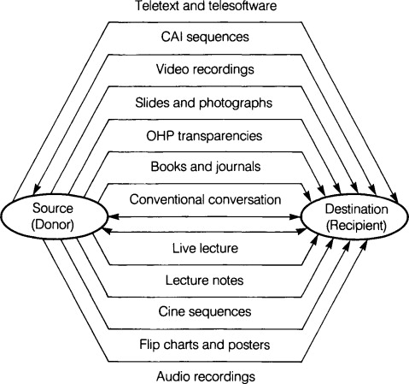

Figure 1. Directionality of some common media

1. **Types of Technique**

There are five types of CAI. Each methodology can be used for games, storytelling and educational. It also has its own particular strengths and are discussed briefly below. The five types are:

* 1. Tutorials
  2. Drills
  3. Instructional games
  4. Simulations
  5. Tests

**3.1 Tutorials**

Purpose: Present information and guide student  
Example: This lesson on courseware

Tutorials strive to provide sequenced, interactive material, to the learner. The learner is engaged in direct and continual two-way communication with the computer, i.e., an active participant. A tutorial is ideal for presenting new material, allowing students to progress at their own pace, and reviewing previously learned subjects.

You can design a tutorial in linear fashion (like a book) or with branching that allows students to control the lesson by their choices. Regardless of the type of design, tutorials should include embedded questions and remediation loops to ensure learners master material before moving on to more difficult concepts.

Advocates of tutorials suggest that they can facilitate learning better than a teacher because of the one-to-one learning. Many tutorials permit students to learn at an individualized rate. When you choose to incorporate a tutorial into your lesson, make sure that it matches your objectives, goals, and content. Review of tutorials prior to using them in class will ensure that they meet your needs. Tutorials are often combined with other types of computer assisted instruction such as drills.

**3.2 Drills**

Purpose: Provide student practice  
Example: Math Blaster; Reader Rabbit

Computer-based drills can take the practice previously found in workbooks and flash cards to a higher level. When used in conjunction with other computer assisted instruction, usually a tutorial, drills are not intended to teach new material. Drills are designed to give students the opportunity to practice what they've already learned. Some of the arguments for using the drill software is that the software can determine the proper level of difficulty based on student ability, ensure completion, provide feedback to mistakes, suggest supplemental activities, and depending on its' design, record student results. Some drill software lets you incorporate randomly generated questions, interactive graphics, pacing and time measured responses, and student progress updates.

Many drills are used in subjects such as mathematics, foreign languages, spelling, grammar, and vocabulary, but they are suitable for practically all subjects that require the student to memorize facts.

**3.3 Instructional Games**

Purpose: Provide student practice and present information  
Example: Where in the world is Carmen SanDiego

Instructional games provide students a means to practice previously learned material or gain new information. But unlike drills, games are competitive by design, pitting the student against the computer, another player, or time. Instructional games are difficult to design, and all too often, even those which are professionally designed turn out not to be fun and become another piece of unused software. Instructional games come in many varieties such as adventure, arcade, board, card or gambling, combat, logic, role-play, psychomotor, TV quiz, and word games. Like drills, these can be adapted to any subject that requires repeated practice.

**3.4 Simulations**

Purpose: Present information, guide the student, and provide student practice  
Example: Oregon Trail

Simulations are unique in that they attempt to give the student a chance to participate in a real-life decision-making situation. They are an effective way of learning because. they require problem solving and decision making. Also, they provide a non-threating learning safe environment. Students can easily work in groups to solve simulation problems. Whole class discussions can assist in helping students prepare for the simulation and help them understand what happened after the simulation.

When utilizing simulations, it may be difficult to assess student learning using traditional evaluation methods. Alternative assessment strategies may be required to ensure that the objectives of instruction have been fulfilled.

**3.4 Tests**

Purpose: Assess student learning  
Example: Graduate Records Examination

Using the computer to construct or administer tests offers the advantages of automatic scoring, randomly generated test items, testing at students' convenience, cross reference of test items to learning objectives, and ease of test bank maintenance. There are numerous testing software packages that can be utilized in the classroom.

1. **Benefits**

It improves learning. Numerous studies over the years have shown that when interactive multimedia is used in the classroom, it is being more enjoyed and it has increased learning. Najjar (1996:30) found that "learning was higher when information was presented via computer-based multimedia systems than traditional classroom lectures".

It is interactive. *Numerous studies have found that interactivity has a strong positive effect on learning (Bosco, 1986, Fletcher, 1989, 1990, Stanfford, 1990). For example, Bosco (1986) reviewed 75 learning studies and found that learners learn faster, and have better attitudes toward learning when using interactive multimedia.*

It is flexible. Multimedia courseware, when on CD, can be used anytime and anywhere. You only need to have computer and you can choose your own time to study.

It is modular. *Each topic or section can stand alone, so managers or trainers can delve deeply into the topic areas they need to learn, and skip over the ones they don't. In many cases applications include the option to custom build the application for your specific use where you can choose modules, and even edit the content in some fields.*

It is practical. It is capable of presenting true to life situations that allow learners to learn best when faced with real problems. Video simulations, simple animations – they all help learners to learn by doing or coaching. Methods like these are all effective ways to develop practical skills and increase information retention.

Consistent.*All learners learn the same principles and skills. Computer-based courseware typically forces instructional designers to better organise and structure learning materials, and this alone can result in learning advantages.*

It is timely. You can use this program when situations arise, because research has shown that people learn better when they are faced with the similar topic at the moment.

It is engaging. When live-action videos, audio, graphics, feedback, expert advice, questions and answers, have been used, it keeps learners interested and reinforces their skills. Though these methods are exciting and fun, they are challenging at the same time, and it makes the learners to return to the program again and again. Through continual practice, learning is absorbed and integrated into daily performance.

It is cost-effective. Studied have shown that it is less expensive and more effective than traditional classroom learning only.

1. **Examples**
   1. **Learning materials**

Supports the following:

* Structured reading materials
* Animation via animated gifs, dynamic html or Java
* Slide shows with accompanying sound track (html + real audio)
* Training videos (real video - bandwidth permitting)
* Printable materials via pdf
* Self assessment via multiple choice questions
* Live chat sessions with course tutors
* Discussion forums for students following the same courses
* Submitting essays to tutors
  1. **Developing and Running Courses**

It easy to develop learning materials using your Web browser without the need for learning how to master complex proprietary authoring packages. You can enter text and images using your Web browser and see how it appears in place. This is supported via a blend of dynamic HTML, Java applets and dynamically generated pages.

The developer environment allows you to outline your course as modules and units, and to manage its development by a distributed team, for instance tracking when a unit is due, who last edited it and when. You will often want to use external specialists to create graphics and audio-visual materials. Developer environment can help you plan and manage the provisioning of such content. We can even put you in touch with audiovisual consultants in your area.

Once your course is open for business, you can track who has registered for the course, and their performance in self assessment tests (subject to privacy concerns). Courses can be offered on an open basis where new students can register at any time. You can also schedule courses to start at a specified date and to run for a specified period. Courseware.com can help you to attract students via our pages of course summaries.

**5.2.1 Developer Environment**

The following screen shot gives you a rough impression of what the developer environment would look like. This is of course just a screen shot of Internet Explorer with the Favorites shown as a tree view in a split screen presentation.

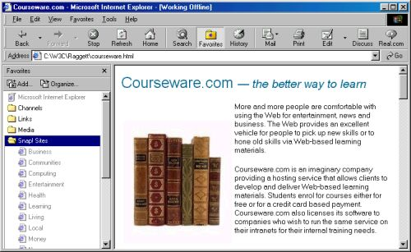

*The left window shows a tree view of the way the course is arranged into modules, units and lessons. It looks very similar to the way Windows shows the hierarchy of file directories. You can open and close levels in the hiearchy and inspect their properties in a pop-up dialog. The right window shows the lesson being worked on. Below it, there is an editing toolbar. This is implemented as a set of HTML frames tied together with scripting.*

* 1. **How it works**

On the server, developer operates a database that covers information about course developers, courses and registered students. Server-side programs generate Web pages dynamically from this database. Cookies are used to identify developers and students, allowing the server to customize pages accordingly without the need for logging in at the start of each session.

On the browser, developer exploits dynamic html to create an attractive and easy to use interface for both developers and students. This allows you to update content and see the results dynamically using a combination of forms and scripting.

* + 1. **Editing slide sets**

One example is an editing interface for creating a series of slides. You start off by clicking on the image of the template you wish to use from a catalog of thumbnail images. This sets the background and the colour scheme. You type the title for a new slide into a form field and hit a button. It is then inserted dynamically into the page before the form field. This step is repeated as many times as needed to create a series of bullet points below the title. Other buttons allow you to move between slides, and to insert and delete slides. HTML Frames can be used as appropriate to separate the editing controls from the content.

* + 1. **Editing tables and graphics**

Other buttons can be used to invoke wizards for creating tables or graphics. The general principle is to rely on scripting where practical, and otherwise to exploit Java. A table wizard for Internet Explorer can be built using scripts to intercept mouse clicks and to dynamically build the table in place in the html document being viewed. A simple graphics editor, similar to the one integrated into Microsoft's PowerPoint, can be implemented as a Java applet. The graphic can be converted into a GIF, PNG or JPEG image at the server.

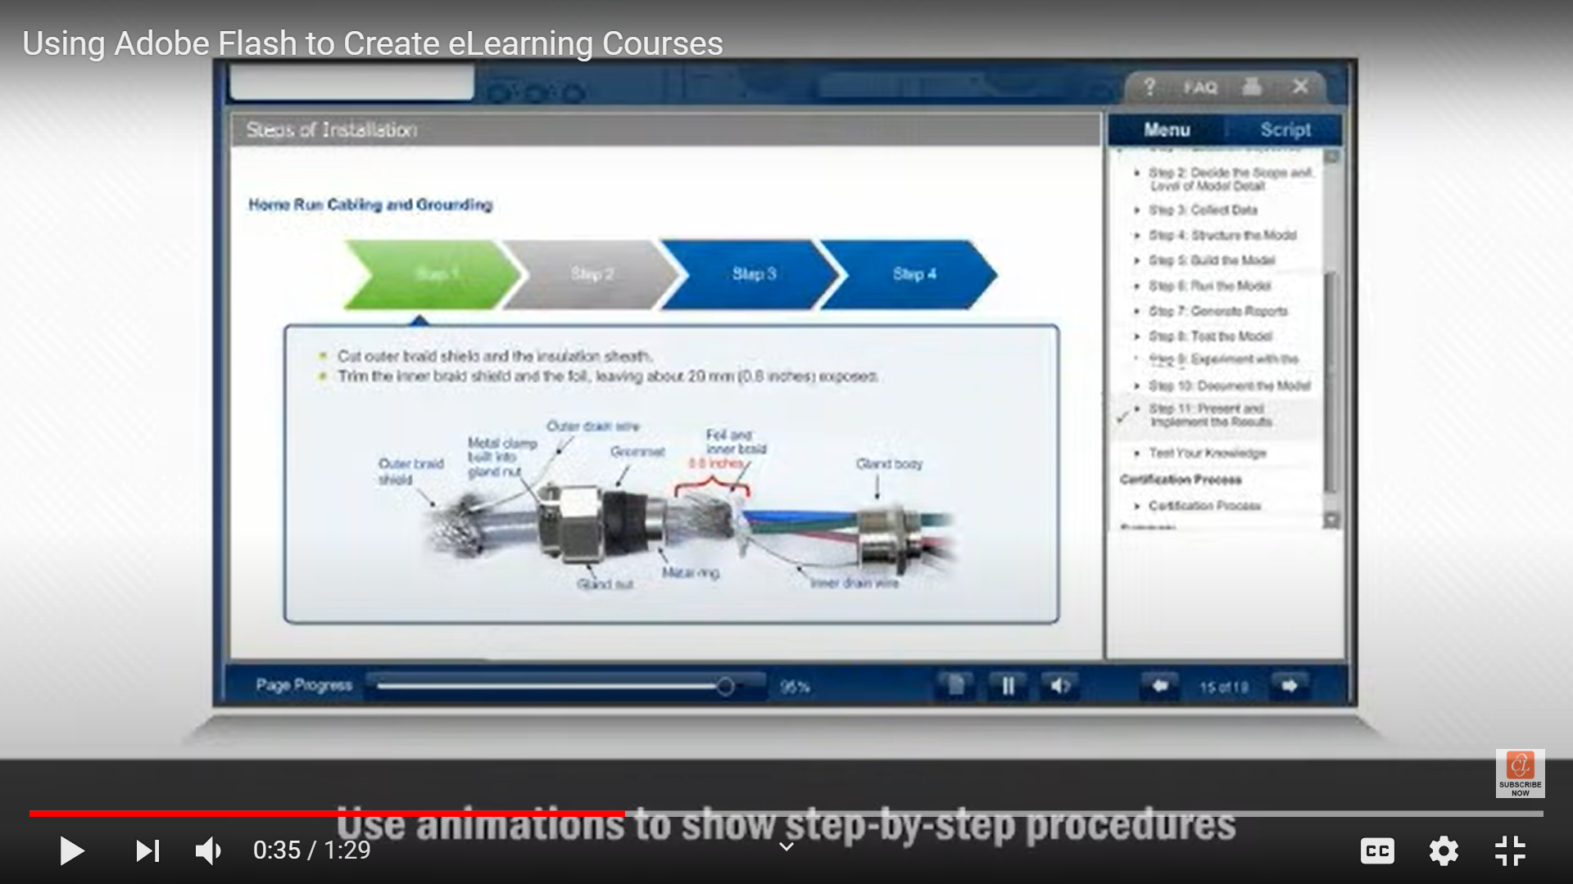

* + 1. **Dynamic notifications of changes**

Some changes to the page can be implemented without the need to reload the new version of the page from the server. The server still needs to be informed of the changes, and one way to achieve this is to use a hidden Java applet that holds open a network connection with the server for passing notifications. This can't be done with scripting along, as currently JavaScript and JScript have limited direct support for networking (what about VBScript?).

In a distributed collaborative authoring enviroment, you may be interested in seeing what changes other people are making, as they are making them. The Java applet used to notify changes to the server can, in principle, also listen for updates due to changes made by other authors. If two or more people make clashing changes, the server can detect this and notify them accordingly — a simple strategy is to roll back to the last consistent state.

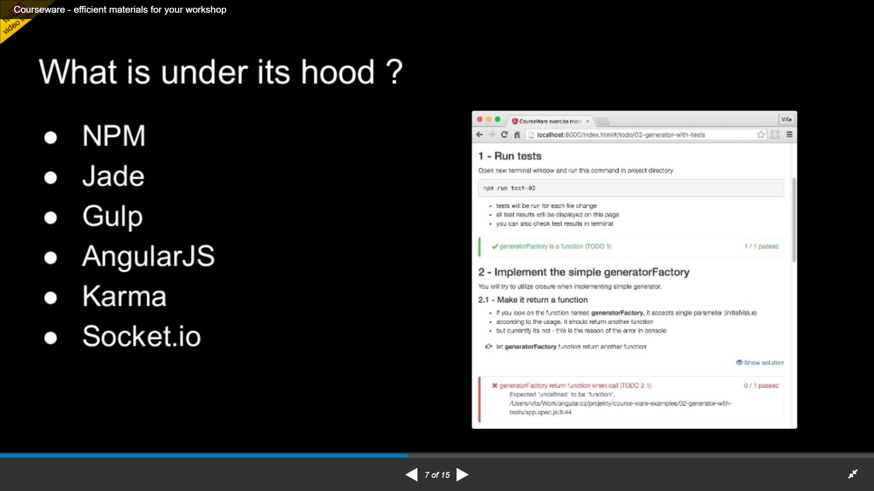

* + 1. **Working around the limitations of Netscape Navigator**

One issue is the limitations of dynamic html support in Netscape Navigator version 4 and earlier. Navigator doesn't support smooth changes to the page, such as adding a new row to table or altering the text in a span element. A work around is to create a new page and load that in place of the current page. This can be done under script control without the need to involve the server.

Navigator 4 also suffers from a weak suport for style sheets. This can be dealt with by careful use of CSS to avoid known problems. If necessary, the server (and/or scripts) can examine the HTTP client request to check for Navigator and to modify the page it generates appropriately.

1. **References**

* “Courseware”, techopediA
* Jae Mu Lee, P2012, “Courseware Learning”, SpringerLink, 2012
* Umesh Rajashekar and Dinesh Nair, P2009, “Courseware”, ScienceDirect, 2009
* “Instructional Courseware Tutorial”
* P2011, “Benefits of interactive multimedia courseware”, English learning can be fun, January 17, 2011
* Dave Raggett, P2000, Courseware.com, 31 March, 2000